Laundry Now
Frank Monforte, Ryan Russell
Electrical Engineering Senior Design Project
Advisor Dr. Farid Farahmand, Client Tramaine Austin-Dillon RLC

Abstract
Laundry Now is a system that is intended to make the process of doing laundry more efficient. It is designed to be used in apartment complexes or dorm housing laundry rooms and it will allow residents to easily check if washers or dryers are available or in use. This system will also report the number of cycles each machine has completed, allowing property management to see which machines are being used and how much. By keeping track of the number of cycles a machine has been used, it can help facility management determine when repairs or maintenance may be needed.

Table of Contents
Abstract 1
List of Figures 3
Lists Of Tables 4
Introduction 5
Body 5
Problem Statement 5
Problem Solution 5
Literature Review/ Existing Patents 5
Marketing Requirements 7
Product Abilities 7
Design Approach 7
Project Overview 7
Sensor Nodes 8
Hardware Communication 15
Wi-Fi Communication 15
User Interface 15
Power 15
Demonstration Unit 16
Engineering Requirements 17
Economic Analysis 18
Social and Environmental Impact 18
Timeline and Gantt chart 19
Summary 20
Reference 22
Appendices 24
Product Comparison 24
Detailed Budget 25
Test and Measurements 26
Flow Charts 28

List of Figures
Diagram 1: System Block Diagram Page 8
Diagram 2: Controller Node to Sensor Node Connection Page 9
Diagram 3: Pin out from Controller Node to Sensors Page 10
Diagram 4: Microcontroller Diagram Page 11
Diagram 5: System Map Page 12
Diagram 6: Server Wiring Layout Page 13
Diagram 6: Pin Connection between Server and Wi-Fi Controller Page 14
Diagram 7: Generating of Test Information Page 26
Diagram 8: Testing Graphed Page 27
Flow Chart 1: Server Page 28
Flow Chart 2: Controller Node Page 29

Lists Of Tables
Similar Product Comparisons Similar Page 6
Marketing Requirements Page 7
Engineering Requirements page 15
Timeline Spring Semester Page 18
Project Milestone Page 19
Product Comparison Page 22
Device Overview Page 22
Detailed Budget Page 23
Laundry Now Device Suppliers Page 23

Introduction
The purpose of Laundry Now is to create a system that helps the user to efficiently use their time when doing their laundry. This system will allow users to predetermine if there are washing machines and dryers that are available for use before having to leave their home. This is to help users determine the best time to do their laundry.

Body

Problem Statement
In many laundry rooms in college dorms and apartment complexes, the only way to tell if a washer or dryer is in use is by going to the laundry room and physically checking if a there is a machine available. It can be frustrating and time consuming having to constantly check the laundry room when waiting for a machine to become available.

Problem Solution
Laundry Now will allow users to check whether there is a washer or dryer open before leaving their home. The system will monitor accelerometers that will be attached to the washers and dryers, and when motion is detected the system will update itself to show that the machine is in use. When a user checks the website from their computer or smartphone, they will see the most recently updated statuses of the machines in the laundry room. Laundry Now will be non-invasive and simple to install because it only requires a single sensor node to be attached to each unit. Due to the non-invasive design, Laundry Now will be inexpensive to purchase and implement, and can be used with both newer and older washers and dryers.

Literature Review/ Existing Patents
Currently on the market there are two different products that are similar to Laundry Now. The first is LaundryView, created by Mac Gray, and the second is Remote Laundry Monitoring System, created by LG. Both of these systems are similar to the product that we are designing, but they each have significant limitations for our targeted market. (1,3)
LaundryView is a system that was developed by Mac Gray as another option that works with the washer and dryers that they supply to colleges and apartment complexes. LaundryView allows users to predetermine if there are any washers or dryers that are available for use. They can do this by checking LaundryView’s website that is continuously updated. This system also allows users to set a notification system that will send a message when the machine has finished the wash cycle or is about to finish the wash cycle. The major limitation of this system is that it requires the washers or dryers that Mac Gray supplies, creating the need to purchase entirely new machines in order to use the system. This significantly increases the financial burden of implementing this system. (1,2) .
The other system that is similar to Laundry Now is LG’s Remote Laundry Monitoring Service, which is a device that allows homeowners to view the amount of time left on the current wash cycle. This device requires the installation of modem into a washer and dryer which will connect with the timer, and then will relay the information over the household power lines to the receiver which needs to be plugged into the wall. This system works well for a single household, but it is not scalable for use in a facility with many machines. (3)
Similar Product Comparisons
Device | Need extra Equipment | Scalable | Internet Capable | Estimated Cost
LaundryView | Mac Gray supplied machines | Yes | Yes | Depends on the number of machines needed
LG’s Monitoring System | No | No | No | $90.00
Laundry Now | No | Yes | Yes | $525 (Full System Parts); $160 (Demo Unit Parts)
(1,2,3,4)

Marketing Requirements
Function | Allows users to predetermine if there are any washers/dryers that are available for use, by checking the website.
Number of Machines | 8 sensors per controller, 4 controllers per server, up to 32 different machines
Wi-Fi Connection | WPS connection
Powered | wall socket
Consumer Cost | $525 (Full System Parts); $160 (Demo Unit Parts)
Size | Server 4” by 4”, controller 4” by 4”, sensor 2” by 2”
Package | Plastic shells
PC and Cell Phone capable | Any device that is internet enabled
Sensor connection | Non-invasive, attached with double stick tape users might be reluctant as this will damage the finish on the machine if left for a long time. Would suction work?
Update Time | The webpage will be updated every 5 minutes to reflect the latest washer/dryer status.

Product Abilities
- Keeps track of the number of machine cycles for days, weeks, and months.
- It will be able to tell if the machine is in operation or is not in operation.
- The website will be able to display the time remaining on every machine.
- Onsite internet connection.
- Website updates every 5 minutes.
- Non-invasive and simple to install.

Design Approach

Project Overview
This product will allow users to see the number of washers and dryers that are in use or available at their laundry facility without having to leave their home. It will do so through sensor nodes that are placed on every washer and dryer and are connected to the SPI interface of the controller node microcontroller. The microcontroller will keep track of which machines are in use, and monitor for vibrations from the door opening and closing to determine when the previous user removes their clothing, leaving the machine available for use. The status of the machines will be stored on the individual controller nodes and the sensors will be checked every 2 minutes. The server will request the latest machine status and update the website every 5 minutes. When a request is received from a user over Wi-Fi, the server will return the HTML website that displays the latest machine status. See Diagram 1 for the basic system design.
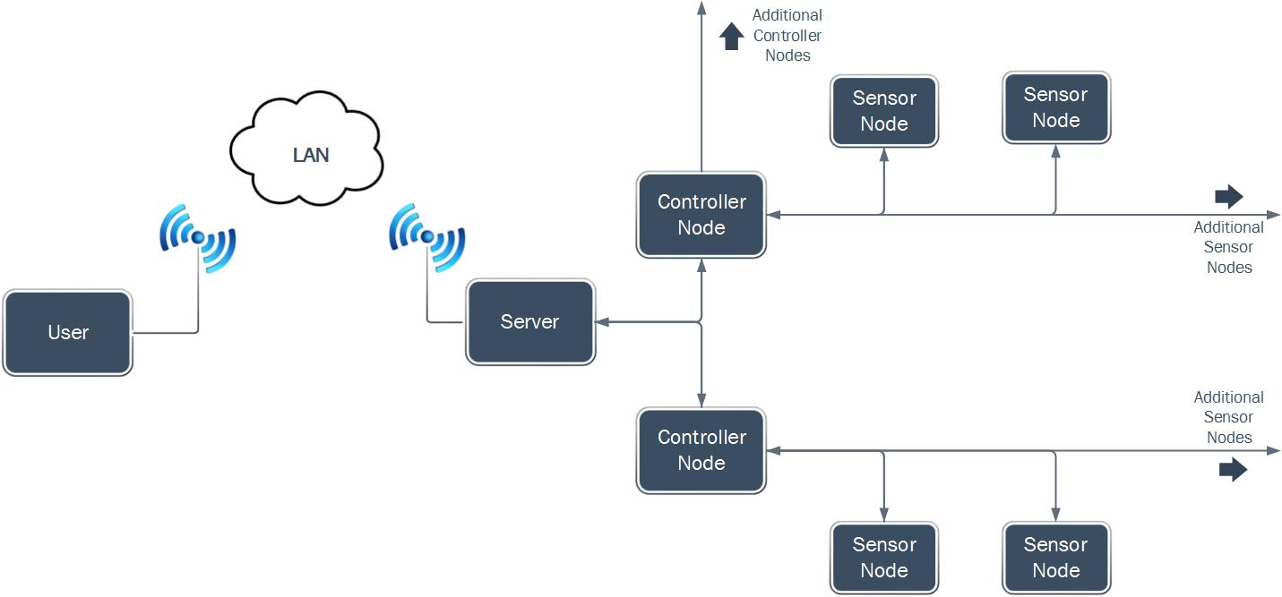
Diagram 1: System Block Diagram

Sensor Nodes
In order for Laundry Now to detect if a machine is running or has stopped and the door opening and closing, it will utilize accelerometers that will be placed directly on the machines. This will also for the system to be non-invasive, inexpensive, and simple to install, but will still allow it to collect enough necessary information. The sensors will be 3-axis MEMS digital accelerometers with built-in SPI interfaces. These sensors are simple, easy to communicate with, and will allow the system to record enough movement data to track the status of the machine it is monitoring. (6,7)
The Clock, MOSI (Master Out, Slave In) and MISO (Master In, Slave Out) lines of the SPI interface will be connected to the sensors in a standard way, however the CS (Chip Select) line will be controlled through a set of multiplexed sensor select control lines to reduce the number of wires being used. There will be 3 control lines total on each controller, allowing up to 8 sensor nodes to be connected. Diagram 3 shows the pin setup from the controller to the sensors. Diagram 2 shows the high level connection between the sensor node and the controller node.
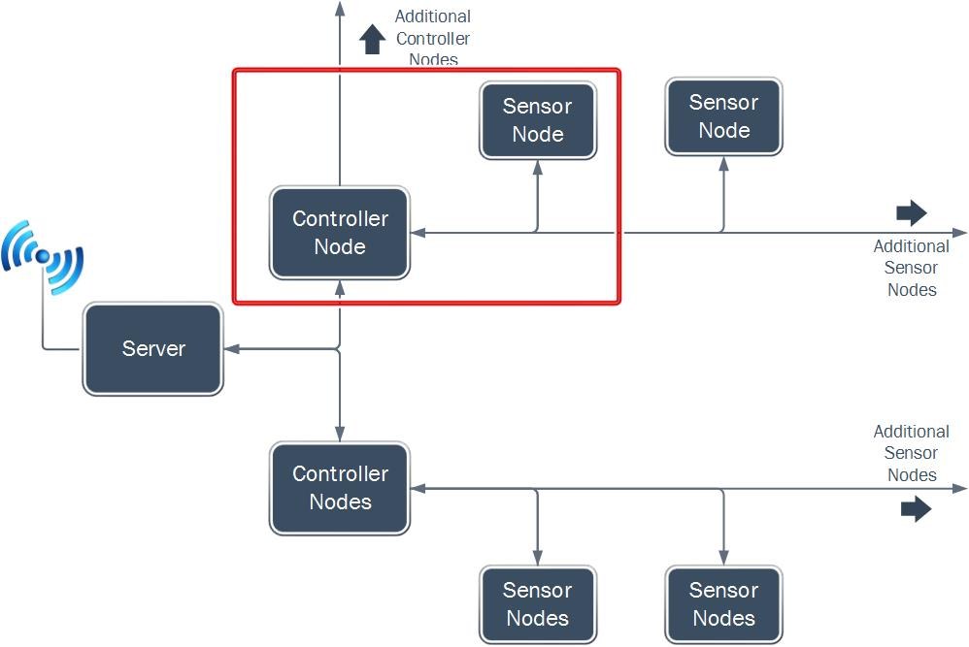
Diagram 2: Controller Node to Sensor Node Connection

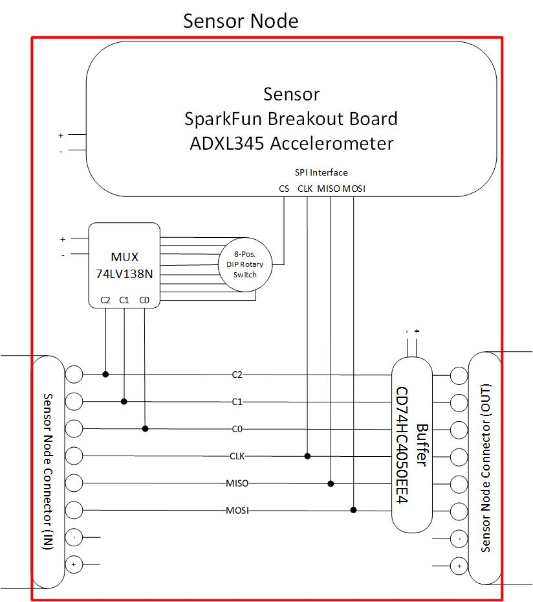
Diagram 3: Pin out from Controller Node to Sensors Node

Microcontrollers
Laundry Now will utilize two types of microcontroller units. The main microcontroller will act as the server, and will store the latest machine status as well as handle data requests from users through a Wi-Fi controller. This microcontroller will be a ChipKIT WF32 produced by Digilent. It features a Microchip PIC32MX69F512L MCU and a Microchip MRF24WG0MA Wi-Fi Controller built on the same chip. It will be programmed with Microchip MPLABX software. Separate microcontrollers will act as control units and will directly interface with the sensor nodes. These will be PIC18F45K20 microcontrollers and will also be programmed using Microchip MPLABX software. The server will be able to handle up to 4 controller nodes at one time, and each controller node will be able to communicate with up to 8 sensor nodes. The high level diagram containing the microcontrollers is shown in Diagram 4 and the pin setup is shown in Diagram 5 and Diagram 6. Diagram 7 shows the practical system application. (8,9,10,11)
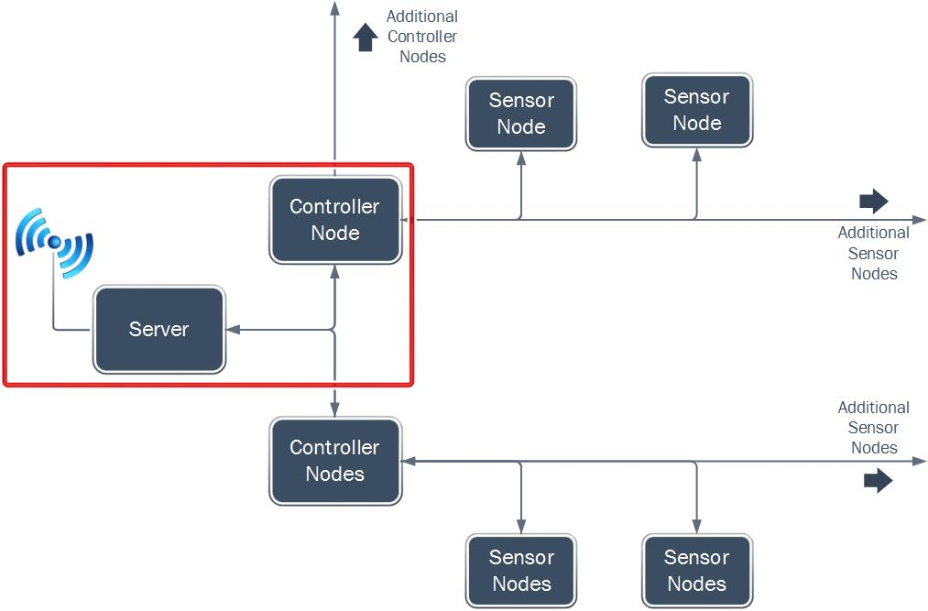
Diagram 4: Microcontroller Diagram
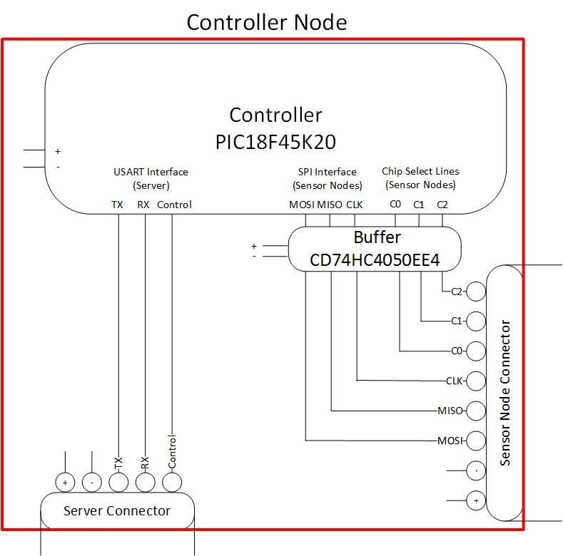
Diagram 5: Pin Setup Server to Controller Node
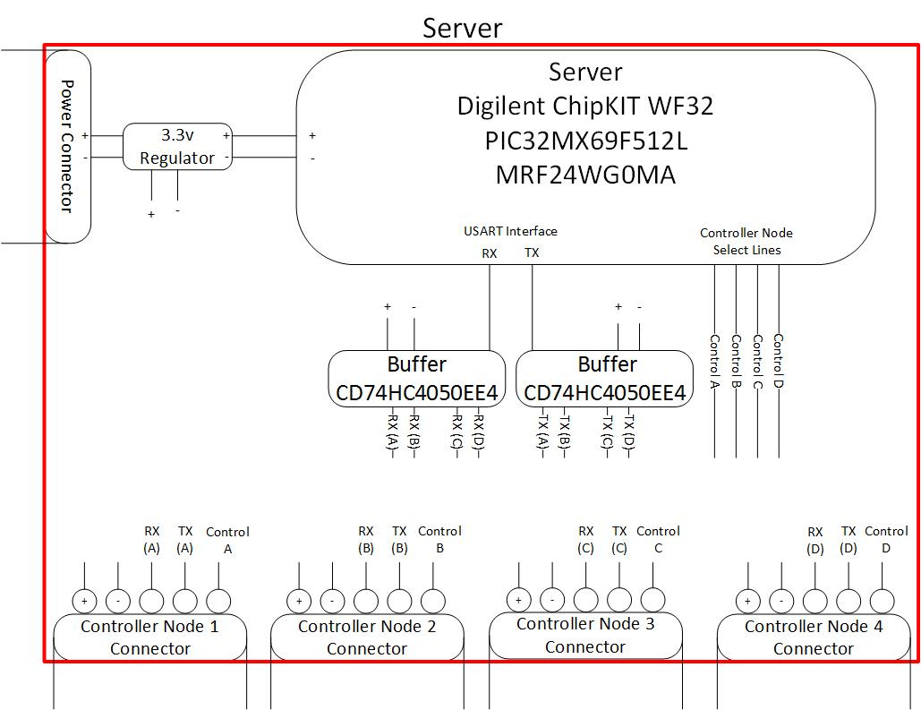
Diagram 6: Server Wiring Layout
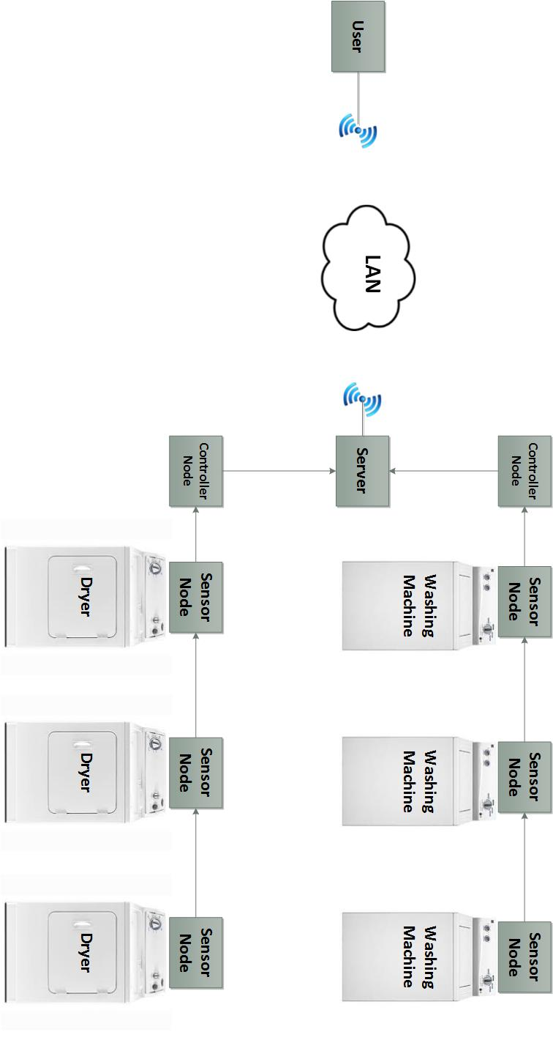
Diagram 7: Practical System Map

Hardware Communication
The microcontroller that interfaces with the sensor nodes directly will do so using the SPI communication interface available on the PIC18F45K20 and the sensor breakout boards. The microcontroller will cycle through each accelerometer on the SPI bus using three multiplexed control lines over the SPI interface. Each cycle of data will be collected, and then stored on the controller node. The machines will be continuously monitored for changes in motion to determine if a machine is in use. It will check for a spike in movement after a wash or dry cycle is completed to determine if the door has been opened and the machine is available. The machine status is retrieved by the server over a serial UART interface and the website stored on the server is updated accordingly. (8,9)

Wi-Fi Communication
The Wi-Fi communication will be handled entirely by the main server microcontroller. When a user attempts to access the site from their computer or smartphone, the data stored on the server microcontroller will be sent to the Wi-Fi controller over the SPI communication interface. This is transfer is handled within the Digilent WF32 board. Laundry Now will support push button WPS (Wi-Fi Protected Setup) connections, allowing the user to press the WPS button on the server and the WPS button on the router to setup the Wi-Fi connection for simple network setup. (10)

User Interface
Users will be able to access the information generated by Laundry Now through a website that is accessible from either a computer, tablet, or smartphone. The website will show which washers and dryers are currently in use. When the user enters the IP of the server microcontroller, the microcontroller will return an HTML webpage that displays the machine status.

Power
Laundry Now will be powered by a wall outlet. This will allow the system to continuously run without the need to change a battery. The main power source will be connected to the server unit which will then provide power the controller nodes along with the sensor nodes. The server node, controller node and the server all require 3.3 volts which allows for the ease of data communication between the components.

Demonstration Unit
As proof of concept, we will be building a demonstration unit that utilizes the different parts of this design. The demonstration unit will have one server microcontroller controlling the system. There will be two control nodes (the system will be capable of a maximum of four controller units) with two sensor nodes connected to each controller node unit (capable of a maximum of eight sensors per controller). The demo unit will require a single available wall outlet power source to power the server and connected components. There will also need to be an available Wi-Fi network provided by a router that is push button WPS capable. A video will be created showing the demonstration unit being used.
Laundry Now will be able to detect if the washer or dryer is in operation or is off and will be able to detect the door opening and closing. It will not be able to directly detect if the load has actually been removed from the machine. By analyzing the movement data it will make the best determination of whether the machine is in use, has completed a cycle, or is empty. This information will then be sent to the server which will post if the machine is in use or waiting to be empty (before the door is opened and closed) or currently available (after the door has been opened and closed).

Engineering Requirements
Controller Node to Sensor Node communication | Data flow is through SPI, Sensor node selection is through a demultiplexer
Controller to Server communication | USART
Wi-Fi requirements | Needs WPS based router
HTML Page | Stored and updated on server
Sensor Node dies | If the sensor node does not respond then then the website will be updated to show an error that sensor could not be updated.
Storage capability | Onboard
Out of service indication | If a controller node does not communicate with the server then the website will be updated to show an error that a controller node could not be updated.
Update Time | The server will update the HTML file every 5 minutes.  The controller nodes will check the sensor nodes every 2 minutes.

Economic Analysis
This product is designed to compete with LaundryView, which is a similar product. LaundryView is a system that was create by Mac Gray to work with the washers and dryers that they supply. Mac Gray is a laundry facility service provider which works with some schools and apartment complexes to maintain their laundry faculties. They provide the machines and maintenance on the machines. Their LaundryView system is only designed to work with the machines that they install. They currently do not quote a price on the cost per machine and the price of the LaundryView system, but the machines they install are either Maytag or Speed Queen washers and dryers. The average price of a new Maytag or Speed Queen washer is about $1500.00 per unit, and the average for a Maytag or Speed Queen dryer is about $1500.00 per unit. We wanted Laundry Now to be less expensive than LaundryView. Because of this, our product is designed to work with preexisting washers and dryers in a laundry facility so there is no need to purchase new washers and dryers. The parts cost for a fully expanded Laundry Now system is about $525 at the current parts cost. Using the chips directly (not on breakout boards) would make the cost of Laundry Now be lower. (1,2,4)

Social and Environmental Impact
Laundry Now is designed to compete with LaundryView, which is a system that have already been installed and is used on college campuses and apartment complexes. Because of this it will have a similar social and environmental impact to LaundryView which has been greatly successful at reducing the time required by users to do their laundry, and increasing the efficiency of the laundry facilities. (2)

Timeline and Gantt chart
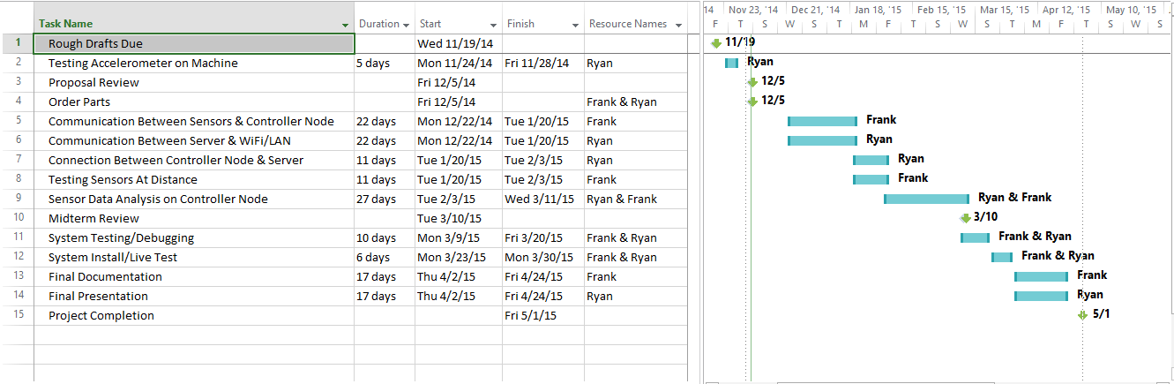

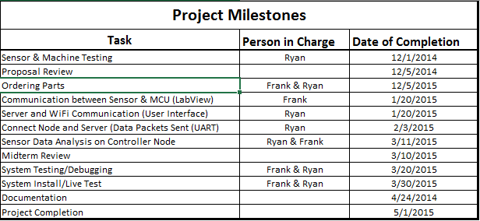

Summary
Laundry Now will allow users to predetermine if there are washers or dryers that are not in use, or to determine that all of these machines are being used. This product is designed to be placed on any washer and dryer units, including older washers and dryers that are not Wi-Fi enabled. There will be an accelerometer that will be placed on every machine that will then allow the controller node monitor the washer/dryer movement. The controller node will collect this movement data from the sensor every 2 minutes. It will analyze the data and update the status of the washer/dryer to one of three states: In Use, Cycle Completed, or Available. It will store this information until the server requests it. Every 5 minutes the server will request the latest machine status from the controller nodes and update the HTML webpage file. When a person checks the website the server will send the latest HTML file showing the status of the machines. It is important to note that the system will not be able to directly tell if a machine has been emptied. It will monitor the movement of the washer or dryer and make a best determination if it is running, has completed a cycle, or is empty. An example of the webpage is below.

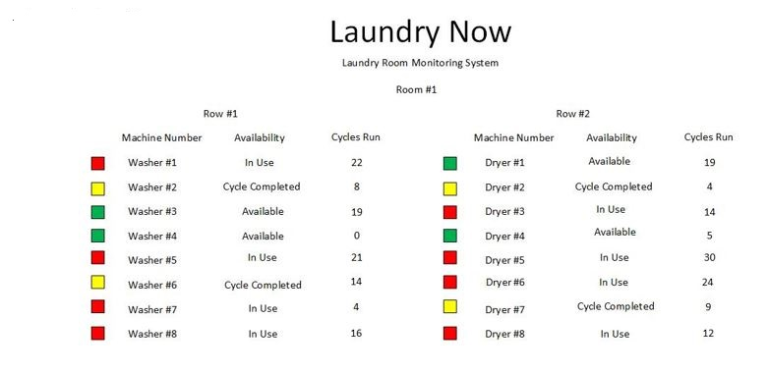

Reference
- http://www.macgray.com/
Mac Gray is the inventor and supplier of LaundryView and all of the products needed to run LaundryView. 11/15/2014
- http://www.campus-solutions.net/index.html
Campus-solutions is one of the many features that is offered by Mac Gray. This website shows how LaundryView has been implemented in Colleges across the country and how it has improved the efficiency of college laundry facilities. 11/15/2014
- http://www.amazon.com/LG-Electronics-RLM20K-Laundry-Monitoring/dp/B0012OMY2K
Is the main selling source for LG’s Remote Laundry Monitoring System, provides cost along with description of what the product does and some reviews form customers. 11/15/2014
- http://www.maytag.com/Laundry-1/Laundry_Laundry_Appliances_Washers-3/102120050+4294966015/
Provides the estimated cost of the Maytag washers and dryers that Mac Gray offers as part of their laundry facility service, and the machines needed to allow for the use of LaundryView. 11/15/2014
- http://www.nmhc.org/Content.aspx?id=4708
This link provides the number of residents the live in apartment complexes in the state of California and the whole country. 12/4/2014
- http://www.analog.com/static/imported-files/data_sheets/ADXL345.pdf
Analog Devices ADXL345 Data Sheet. 12/1/2014
- https://www.sparkfun.com/products/9836
SparkFun Product Page & Details for ADXL345 Breakout Board. 12/1/2014
- http://ww1.microchip.com/downloads/en/DeviceDoc/41303G.pdf
Microchip PIC18F45K20 Data Sheet. 12/1/2014
- http://ww1.microchip.com/downloads/en/DeviceDoc/61156H.pdf
Microchip PIC32MX69F512L Data Sheet. 12/1/2014
- http://ww1.microchip.com/downloads/en/DeviceDoc/70686B.pdf
Microchip MRF24WG0MA Wi-Fi Controller. 12/1/2014
- https://www.digilentinc.com/Products/Detail.cfm?NavPath=2,892,1193&Prod=CHIPKIT-WF32
Digilent ChipKit WF32 Product Page. 12/1/2014

Appendices

Product Comparison

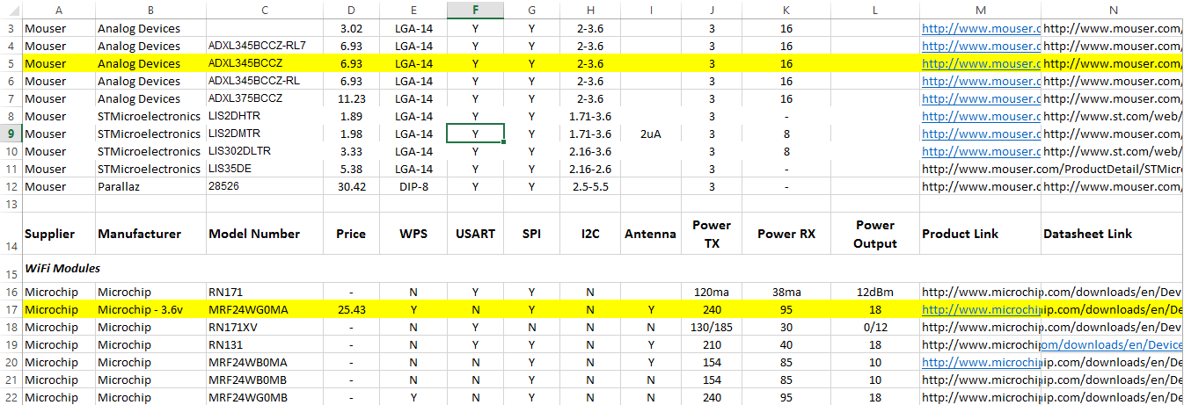

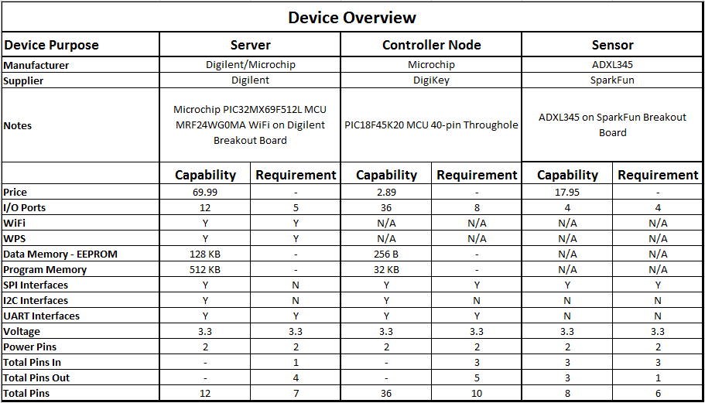

Detailed Budget

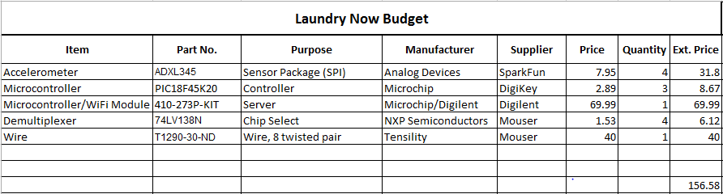
This budget reflects the cost of parts using breakout boards and pre-assembled parts to make the demo unit (1 server, 2 controller nodes, 4 sensor nodes). If Laundry Now was to be implemented in a full scale commercial product breakout boards and pre-assembled boards would not be needed and the cost for the chips would drop, allowing the overall cost for the system to be cheaper. The budget below shows the cost using current parts (breakout boards/pre-assembled boards) for a fully expanded system (1 server, 4 controller nodes, 32 sensor nodes).
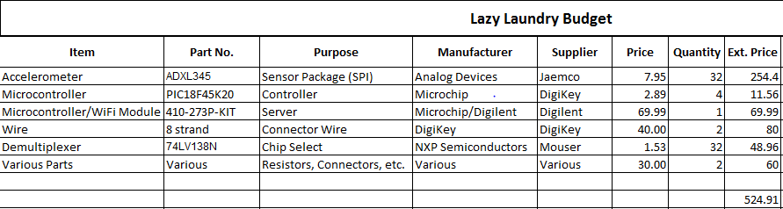
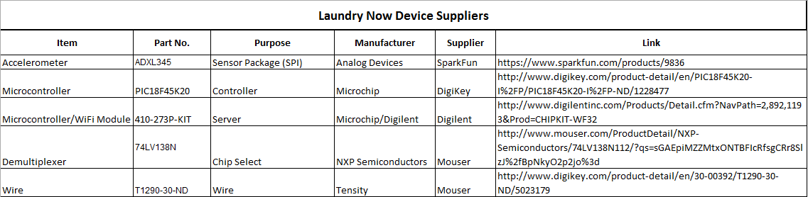

Test and Measurements
In order to be sure the microcontrollers could properly collect valid movement data from the machines we tested a similar accelerometer. We used an Arduino Uno microcontroller with a simple script to monitor the machine, collect the data, and transmit it back to a laptop where the data points could be analyzed. Using MATLAB, we plotted the data points across the clock cycles to see if the vibrations created by the machine could be easily analyzed. We found that we could easily see the movement of the machine when it was running and the quick spikes in movement when the door was opened and closed. This data will allow us to do some simple processing on the controller node MCU to determine if a machine is in use or available. The sensor that was used was a Parallax 2-axis MEMS digital accelerometer that provided an output similar to what the Analog Devices 3-axis MEMS accelerometer will output. Diagram 8 is a screenshot take during the data collection process and Diagram 9 is the graph representation of the collected data.
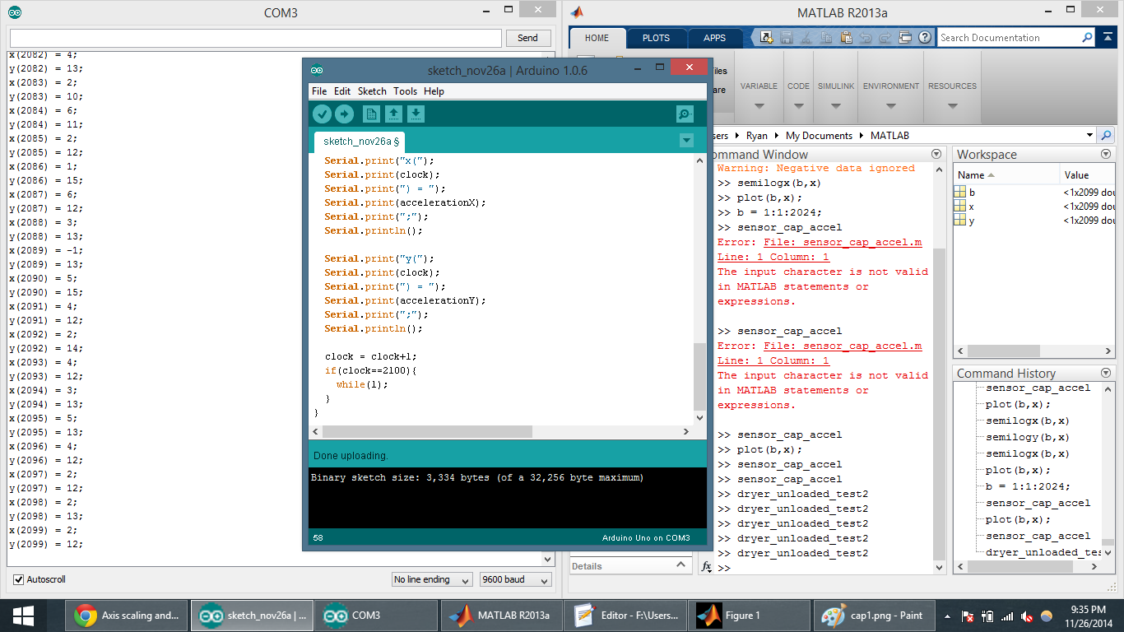
Diagram 8: Generating of Test Information
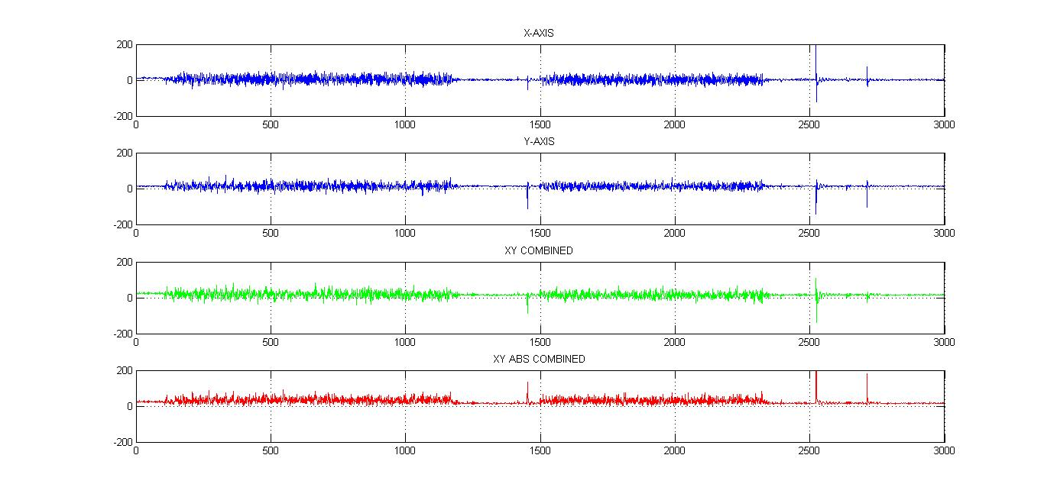
Diagram 9: Testing Graphed
The first two graphs are the raw data output of the X and Y axis of the accelerometer. The third graph is one method of analysis to emphasize the spikes by summing the axes. We found that while this helped amplify certain parts of the data, it cancelled out in other cases. In order to get around this, we added the absolute value of the two axes. This produces a much better output that can easily be analyzed by the controller node.

Flow Charts
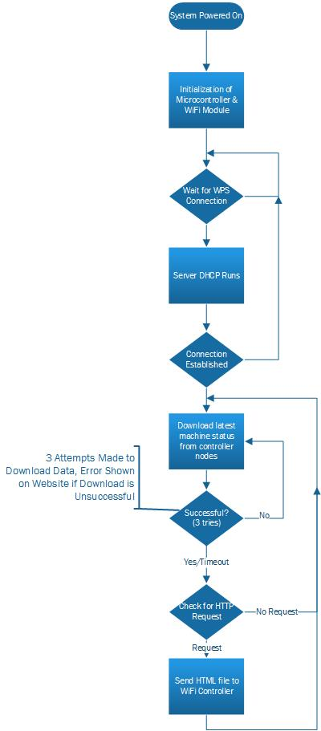
Flow Chart 1: Server
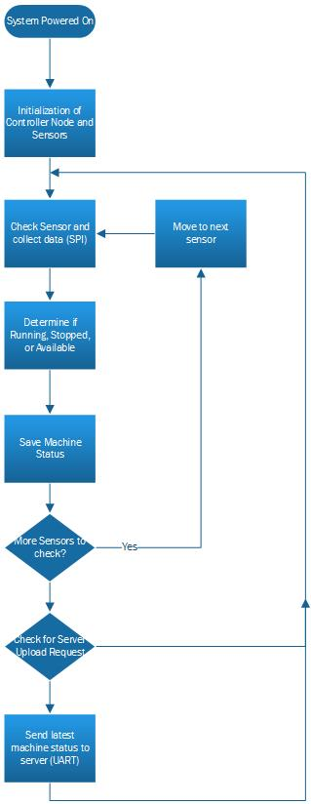
Flow Chart 2: Controller Node to Sensor Node

